## DAILY ONLINE ACTIVITIES SUMMARY

|  |  |  |  |  |  |  |  |
| --- | --- | --- | --- | --- | --- | --- | --- |
| **Date:** | **5/06/2020** | | | | **Name:** | **Ravi K R** | |
| **Sem & Sec** | **8th- B** | | | | **USN:** | **4AL16CS076** | |
| **Online Test Summary** | | | | | | | |
| **Subject** | | **BDA** | | | | | |
| **Max. Marks** | | **30** | | **Score** | | **16** | |
| **Certification Course Summary** | | | | | | | |
| **Course** | **Ultimate Java programming and certification** | | | | | | |
| **platform** | | | **Eduonix** | **Duration** | | | **10 hours** |
| **Coding Challenges** | | | | | | | |
| **Problem Statement:**  **1)** Java application program check the palindrome number with range 0<=n<=10^6? | | | | | | | |
| **Status: Executed** | | | | | | | |
| **Uploaded the report in Github** | | | | **Yes** | | | |
| **If yes Repository name** | | | | <https://github.com/alvas-education-foundation/Ravi_kr> | | | |
| **Uploaded the report in slack** | | | | **Yes** | | | |

Online Test Details:

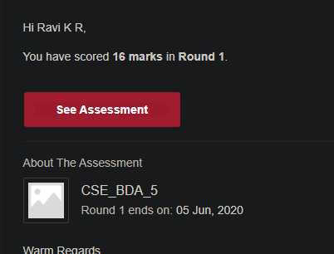

Certification:

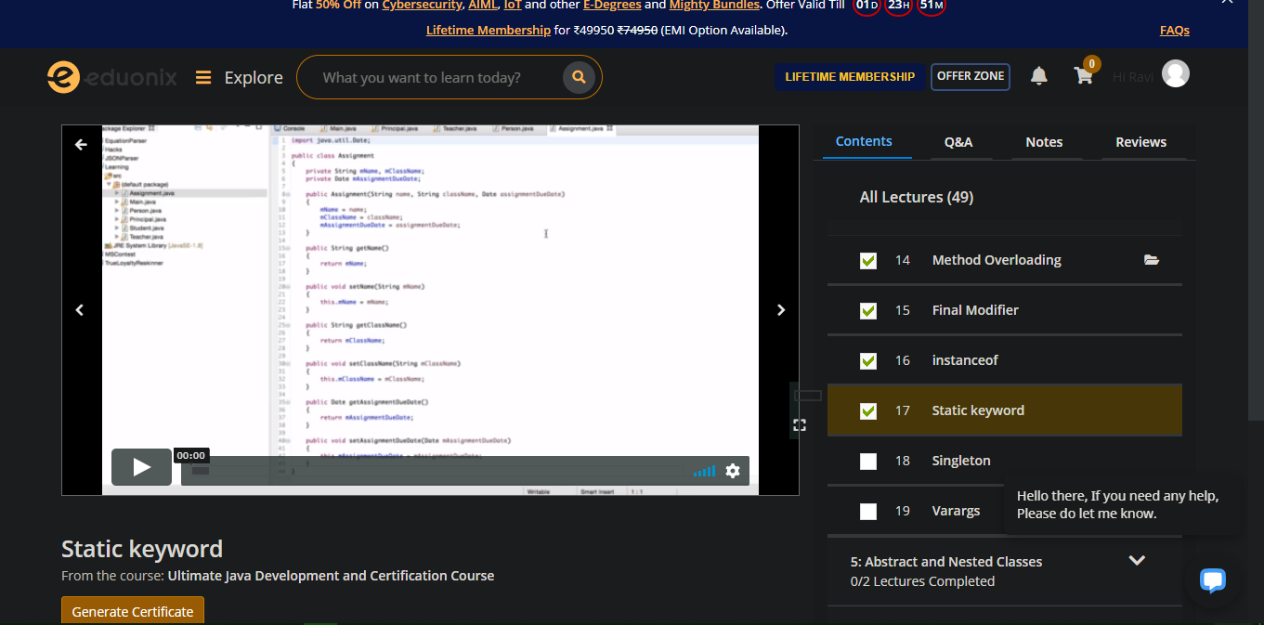

Coding Challenges Details:

